**A**

**PROJECT REPORT**

**ON**

**“WEDDING AND EVENT PLANNING”**

**SUBMITTED**

**TO**

**PROF. SONALI KARTHIK**

**(PROJECT GUIDE)**

**BY**

**THIRD YEAR**

**5th SEMESTER**

**INFORMATION TECHNOLOGY STUDENT ON**

**OCTOBER 2021**



**H. J. THIM TRUST’S**

**THEEM COLLEGE OF ENGINEERING**



**H. J. THIM TRUST’S**

**THEEM COLLEGE OF ENGINEERING**

Chillar Road, Boisar(E).

Dist: Palghar

**CERTIFICATE**

This is to certify that, the seminar work entitled “WEDDING AND EVENT PLANNING” Prepared under the guidance of PROF. SONALI KARTHIK for partial fulfilment of the requirement for the team work of “INTERNET PROGRAMMING” during the year 2020-2021 has been successfully completed.

**PROF. SONALI KARTHIK PROF. TANZEEM SYED (PROJECT GUIDE) (HOD)**

**DR. SHAH AQUEEL AHMED**

**(PRINCIPAL)**

**Preface**

The INTERNET PROGRAMMING (IP) is a system of interrelated computing devices, mechanical and digital machines, objects, animals or people that are provided with unique identifiers and the ability to transfer data over a network without requiring human-to-human or human-to computer interaction

The idea of Wedding And Event Planning is particulary for wedding couple who are willing to have a great or destination wedding. Weddings are significant events in people's lives and as such, couples are often willing to spend considerable amount of money to ensure that their weddings are well-organized. Wedding planners are often used by couples who work long hours and have little spare time available for sourcing and managing wedding venues and wedding suppliers.

***Acknowledgement***

*The success and final outcome of this project required a lot of guidance and assistance from many people and I am extremely privileged to have got this all along the completion of my project. All that I have done is only due to such supervision and assistance and I would not forget to thank them.*

*I respect and thank PROF.SONALI KARTHIK, for providing me an opportunity to do the project work and giving us all support and guidance which made me complete the project duly. I am extremely thankful to her for providing such a nice support and guidance, although he had busy schedule managing the college affairs.*

*I am thankful to and fortunate enough to get constant encouragement, support and guidance from our HOD(PROF. TANZEEM SYED) who helped us in successfully completing our project work. Also, I would like to extend our sincere thanks to him. We are glad enough for you being there always for our help.*

*I would not forget to remember our Principal Dr. SHAH AQUEEL AHMED for their encouragement and more over for their timely support and guidance till the completion of our project work.*

*Lastly I would like to thanks the whole team for supporting and helping us through our needs.*

**A PROJECT ON**

WEDDING AND EVENT PLANNING

Prepared under the guidance of Prof. SONALI KARTHIK for partial fulfilment of the requirement for the team work of “Internet Programming” during the year 2020-2021 by the following students:-

• Dipti Jadhav (203125)

• Sneha Joshi (203127)

•Ashutosh Salunkhe (203162)

•Nisha Yadav (203173)

v

**ON REPORT OBJECTIVES**

1. Wedding and event Planning
2. Introduction
3. Abstract
4. Requirements
5. Services
6. Website pages
7. Conclusion
8. References

vi

1. **WEDDING AND EVENT PLANNING**

Every wedding you plan will be different. Every couple will have different needs. You will have a chance to expand your repertoire through each experience. And you will discover the joy of making others peoples dreams come true. By helping brides and grooms through the maze of planning that a wedding requires, that begins their married life together. Couples expect wedding planners to fulfil their every need and to make sure nothing is forgotten on their special day. Knowing these expectations beforehand will enable you to provide your client with a high quality service; therefore resulting in a well-planned memorable wedding. You are the facilitator of the fairytale and your responsibilities are enormous.

A wedding is one of the most important days in any couple’s lives. From engagement photos, to selecting vendors, to making checklists and choosing your wedding party, there are lots of items that need to be planned out in an orderly fashion up until you say those two magical words – “I Do.”

Planning your own wedding can sometimes feel overwhelming and stressful, but if you follow these stress-free tips below, you will find planning your wedding will be smooth sailing, and more enjoyable from an expert event professional mindset.

**2. Introduction**

Weddings are significant events in people's lives and as such, couples are often willing to spend considerable amount of money to ensure that their weddings are well-organized. Wedding planners are often used by couples who work long hours and have little spare time available for sourcing and managing wedding venues and wedding suppliers.

Professional wedding planners are based worldwide but the industry is the largest in the USA, India, western Europe and China. Various wedding planning courses are available to those who wish to pursue the career. Planners generally charge either a percentage of the total wedding cost, or a flat fee.

Planners are also popular with couples planning a destination wedding , where the documentation and paperwork can be complicated. Any country where a wedding is held requires different procedures depending on the nationality of each the bride and the groom. A local wedding planner can take care of the different procedures.

A Wedding event planner is a professional event coordinator who specializes in planning marriage proposals. A proposal planner is a relatively new profession in the wedding industry. Proposal planners suggest marriage proposal ideas, scout proposal locations, negotiate rates with vendors, draw up contracts, hire photographers, create romantic setups, acquire permits, and help clients choose engagement rings. Proposal planners interview the proposer and ask questions about the couple. They then use those answers to create a unique proposal idea.

The mass media and social media are partly responsible for the emergence of proposal planners. There are fancy proposals on TV, and women's expectations are rising. Men have trouble meeting those expectations without some help.

**3.ABSTRACT**

The wedding planner is a website which helps to organize successful wedding events for users. This application provides an easy way to plan their special events. The user can add all the details of the event and can get the service. The user can select the type of event, type of food to be served, type of decoration and estimated budget. All the details given by users will be verified by admin. Admin will add all the details of the planner based on the requirement of the user and send the user’s event details to the planner. The planner will verify and send his response with a confirmation mail. The user needs to complete the payment process to confirm the order.

In the existing Wedding Event Planner system, users need to waste a lot of time and physical effort in finding the place for the event and no proper information is provided to the user regarding the event details like food, decoration, and budget. All the information is maintained in records which are difficult to view or modify.

**4**.**Requirements**

**HTML, CSS AND JAVA SCRIPT PROJECT ON WEDDING AND EVENT SYSTEM**

This project Wedding and Event Planner has been developing this project was to create a static website for the wedding planner, from which user can get the details of the wedding such as about the wedding planner, venue, theme, dress as per the occasion, detail of the every things available on the this website, contact details, address, images, booking information, etc.

This project is in HTML ans CSS so it’s a static website and does not perform any type of dynamic database operation.We are using HTML for developing website related

**TECHNOLOGY USED IN THE PROJECT WEDDING AND EVENT PLANNING**

* HTML: Pages layout has been designed in HTML.
* CSS: CSS has been used for all designing part.
* JAVASCRIPT: all the validation task and animations have been developed by javascript.

**SUPPORTED OPERATING SYSTEM**

We can configure this project on the following the operating system

* Windows: this project can easily be configured on windows operating system.
* Linux: We can run this project also on all versions of linux operating system.
* Mac: We can also easily configured this project on mac operating system.

**5. Services**

The services of a wedding planner may include:

* Interview the couple and parents to identify their needs.
* Preparation of the budget
* Design and style of the event
* Scouting locations
* Photoshoots
* Planning a detailed checklist (about a year in advance for a few days after the wedding)
* Preparation of the list of participants
* Identification of venues for events (hotels, party house, ceremony, church, temples etc.)
* Identification and contracting of wedding professionals and service providers (suppliers, photographers, videographers, beauticians, florists, sweets, buffet, drinks, etc.) and contract preparation and execution.
* Acquisition of custom decorations, such as a travel map
* Coordination of deliveries / services on the wedding day.
* Have a back-up plan in the event of a disaster.
* Manages programming, often with software.
* Help and prepare legal documentation and translations - especially for destination weddings
* Event layout indicating the location of the dance floor, buffet points, tables, chairs, lounges, etc.
* Event briefing for all suppliers (Contact the wedding week vendors for details and schedules)
* Coordinating wedding day, conference and pre-event assembly follow-up

**6. Website Pages**

LOGO PAGE:-

A **logo** is a graphic mark, emblem, or symbol used to aid and promote public identification and recognition. It may be of an abstract or figurative design or include the text of the name it represents as in a wordmark.

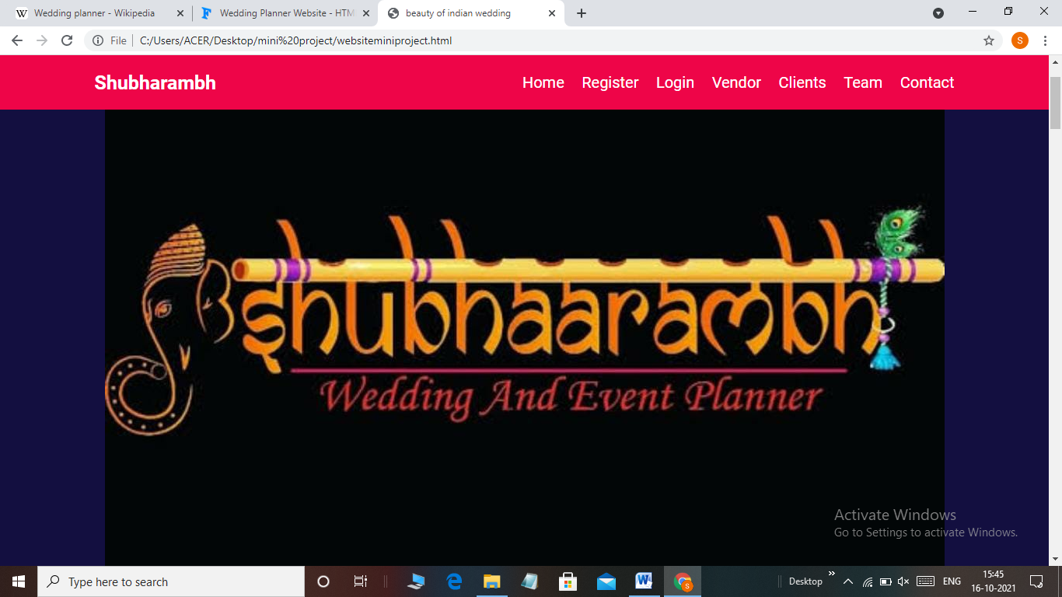

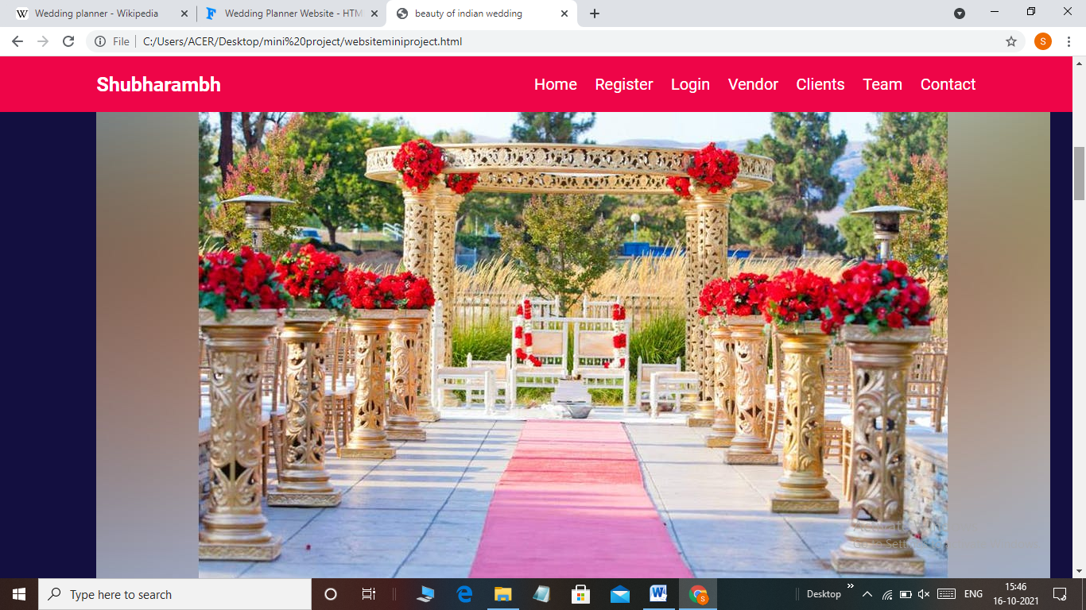

REGISTRATION PAGE:

Registration only happens the first time you access the system.

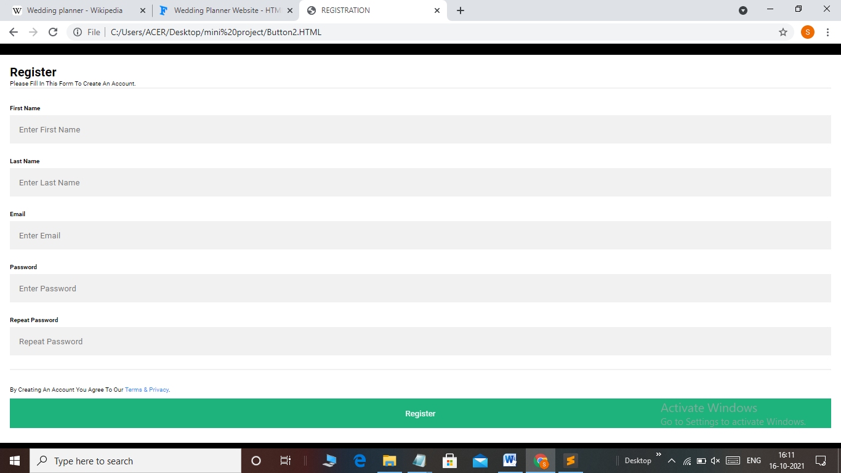

LOGIN PAGE:

 An individual gains access to a computer system by identifying and authenticating themselves.

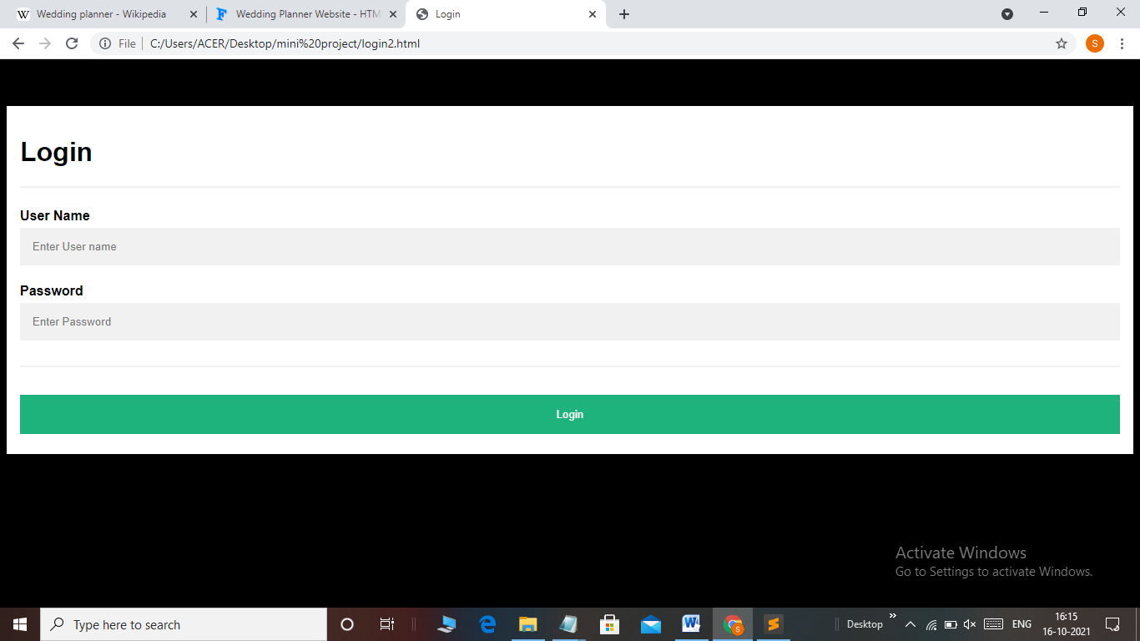

VENDOR PAGE:

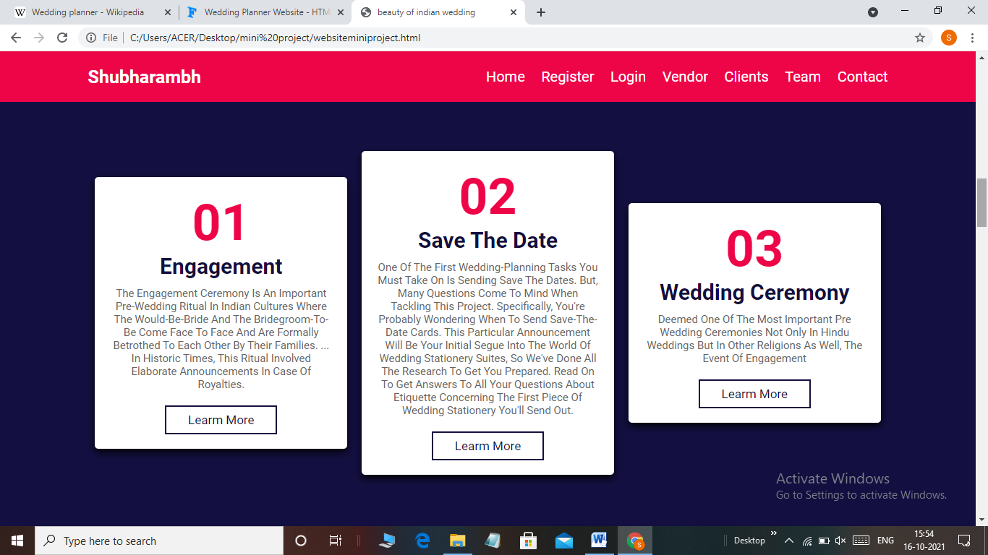

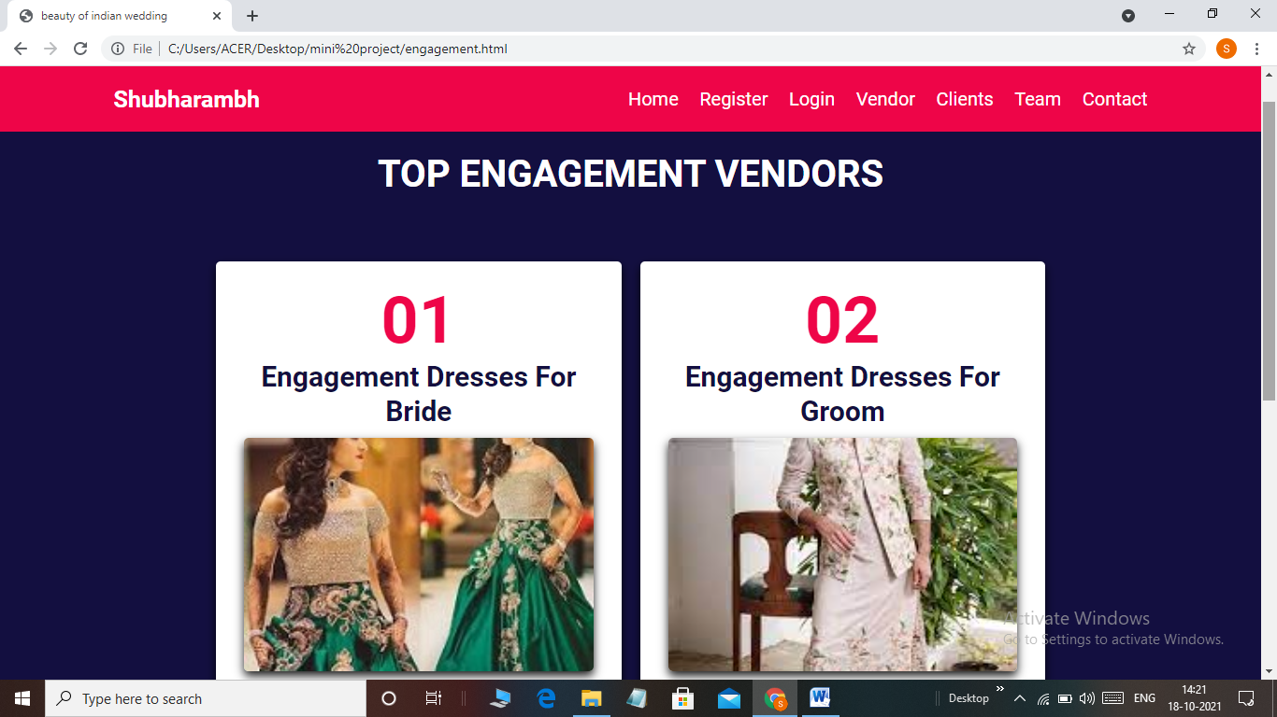

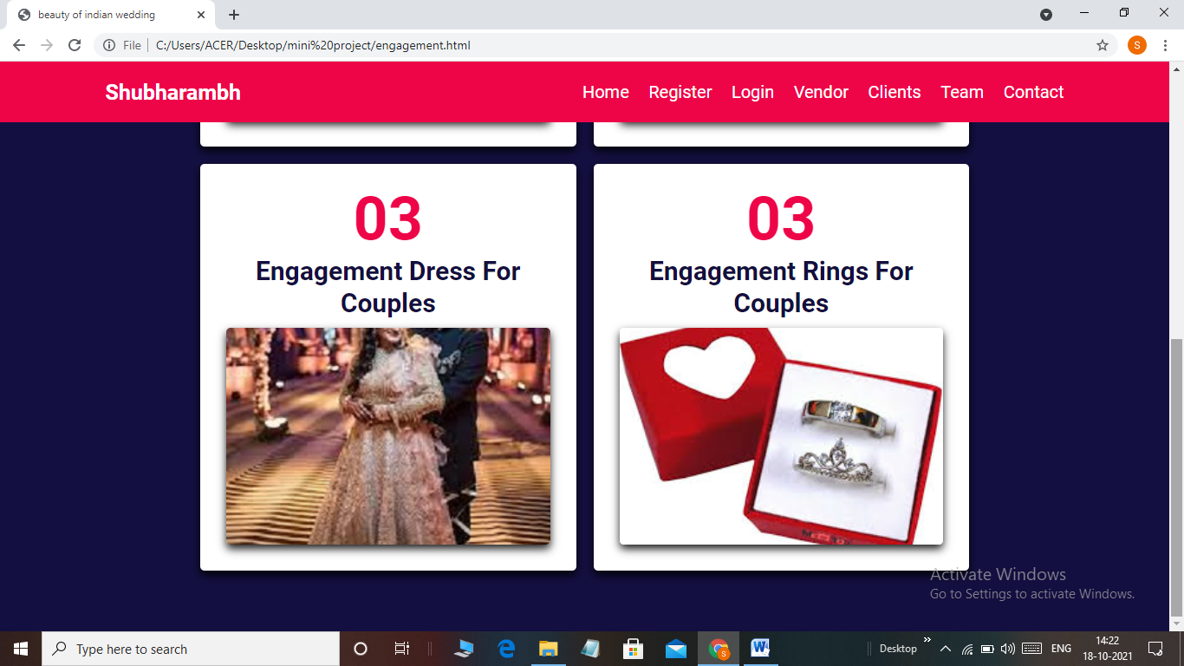

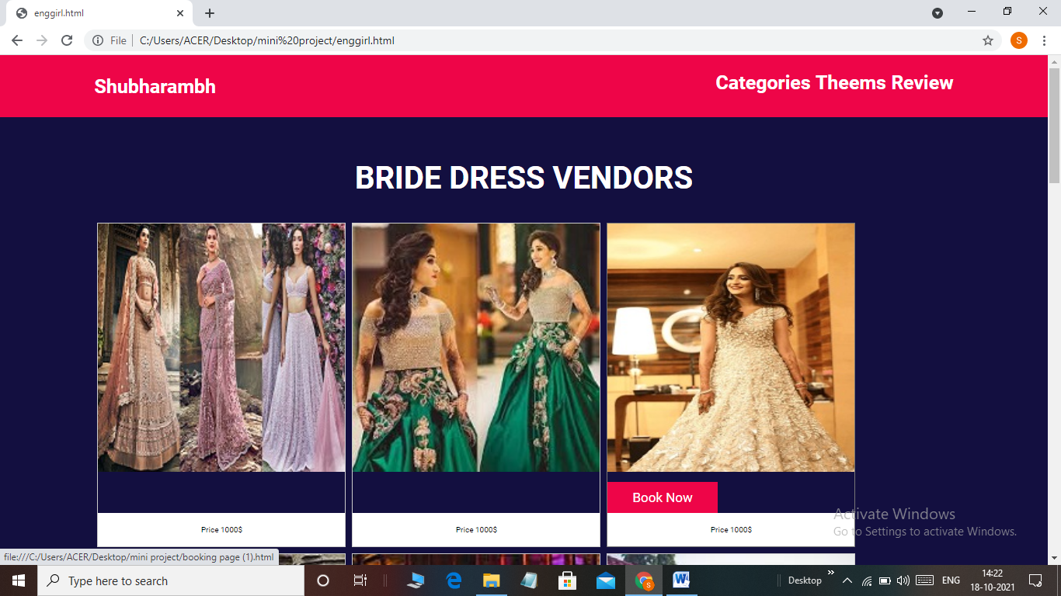

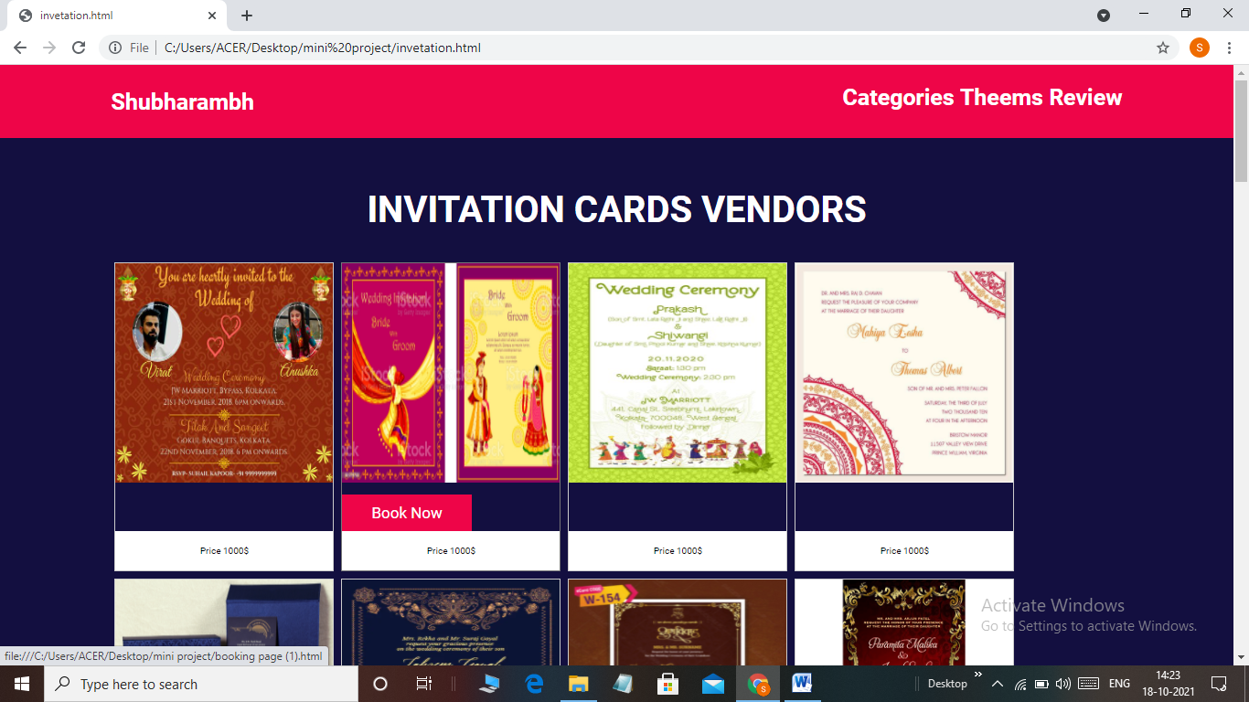

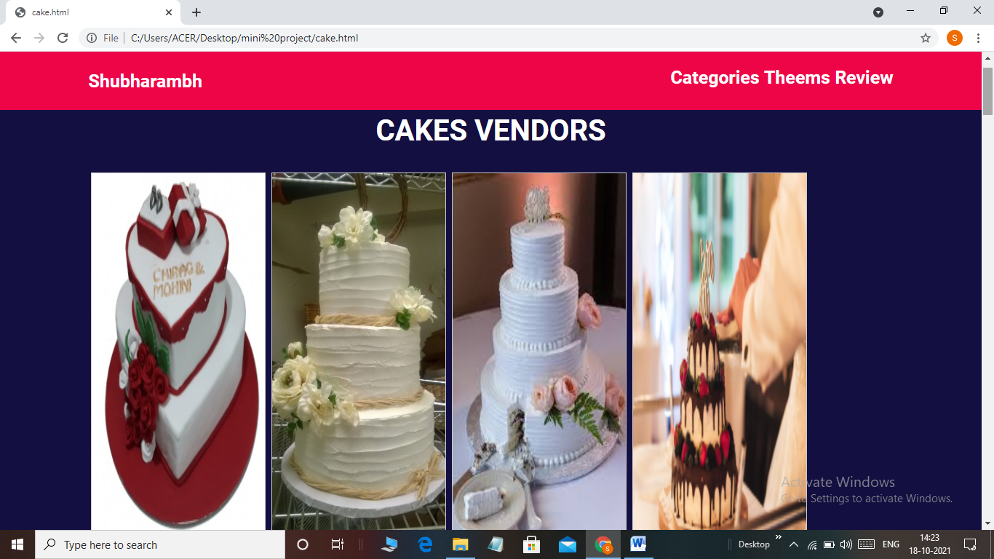

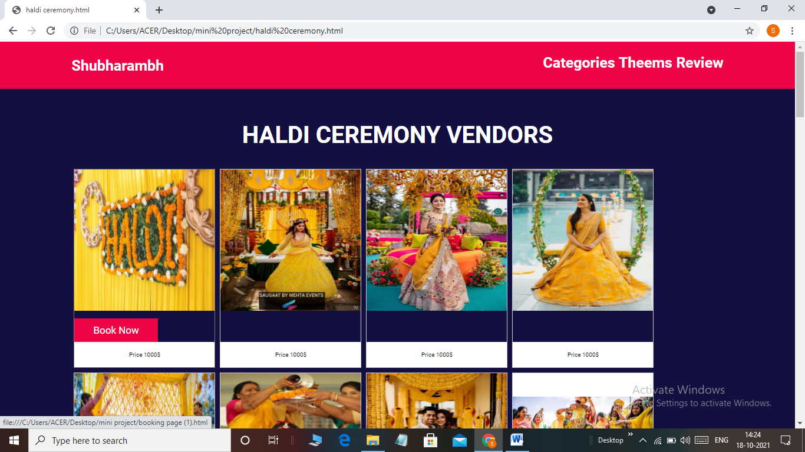

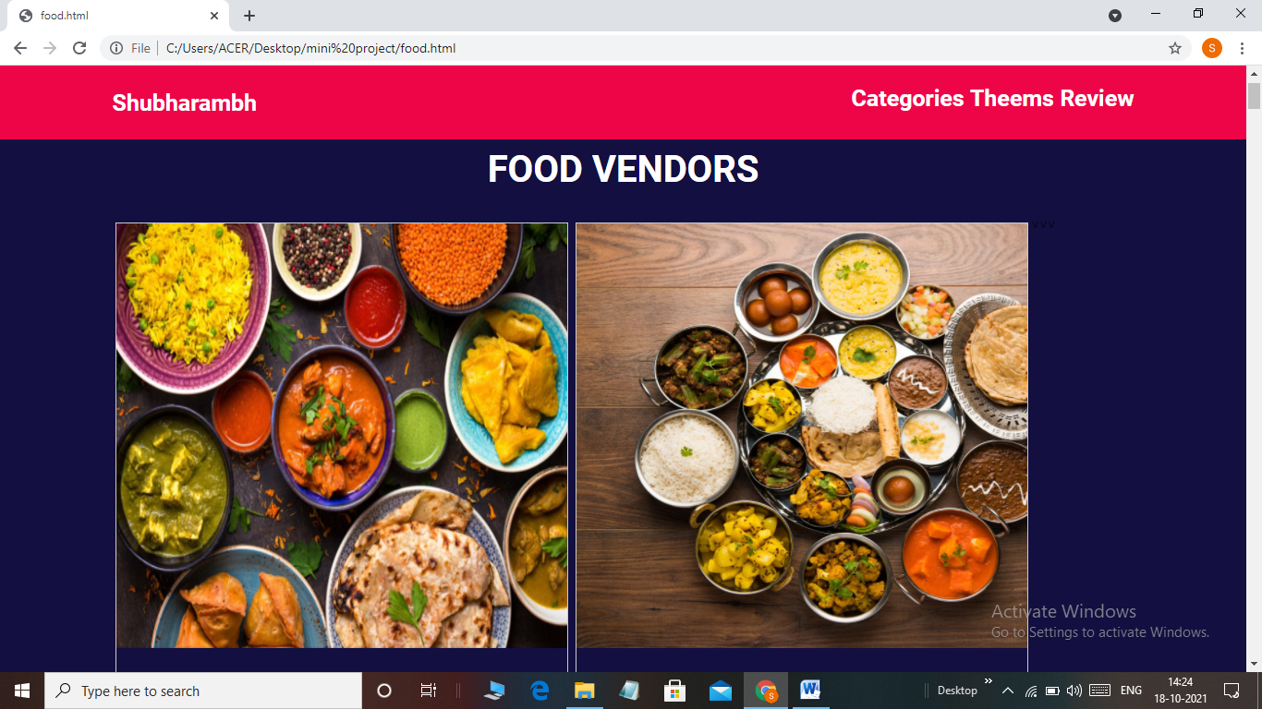

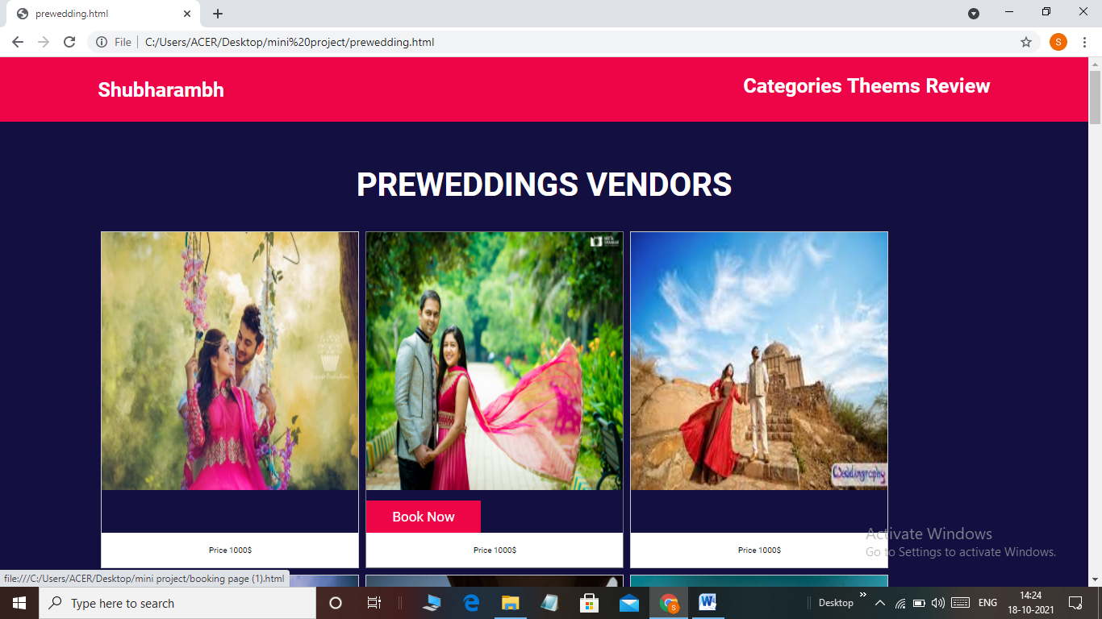

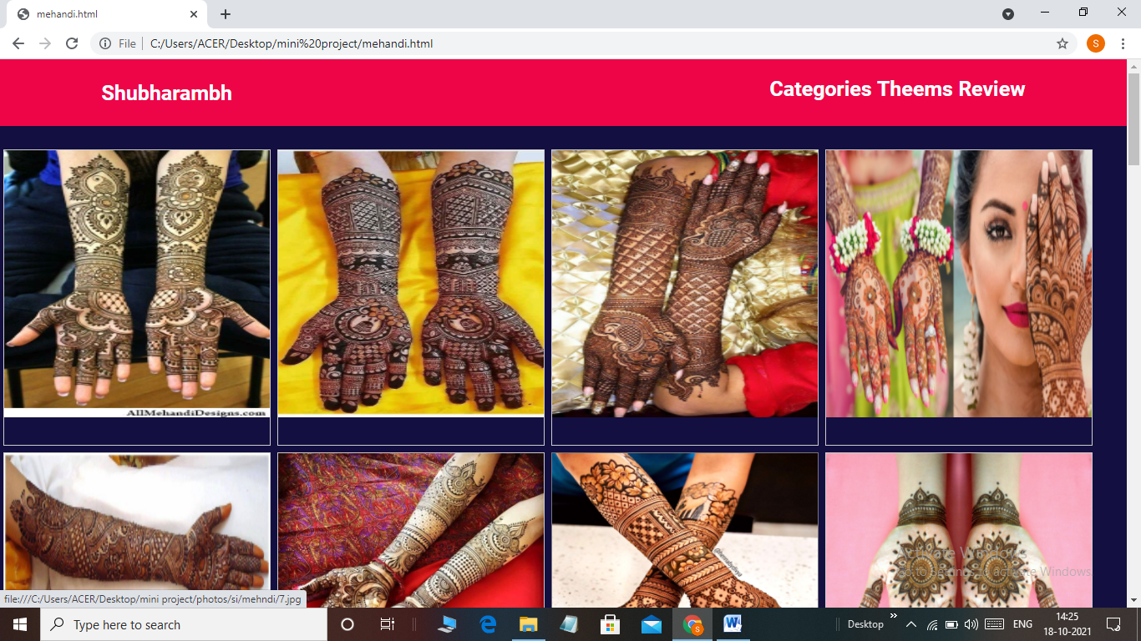

CLIENT PAGE:

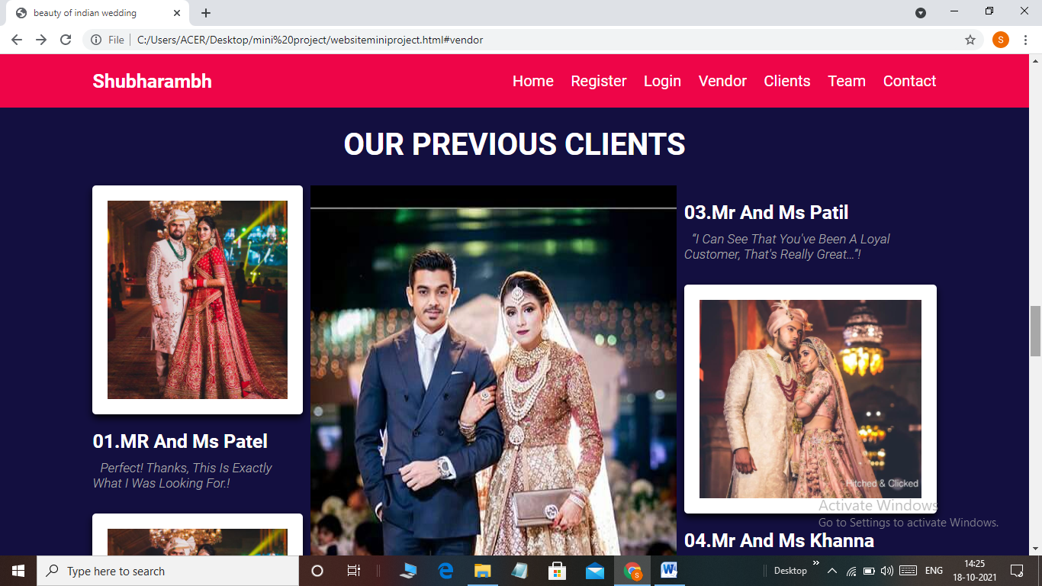

TEAM:-

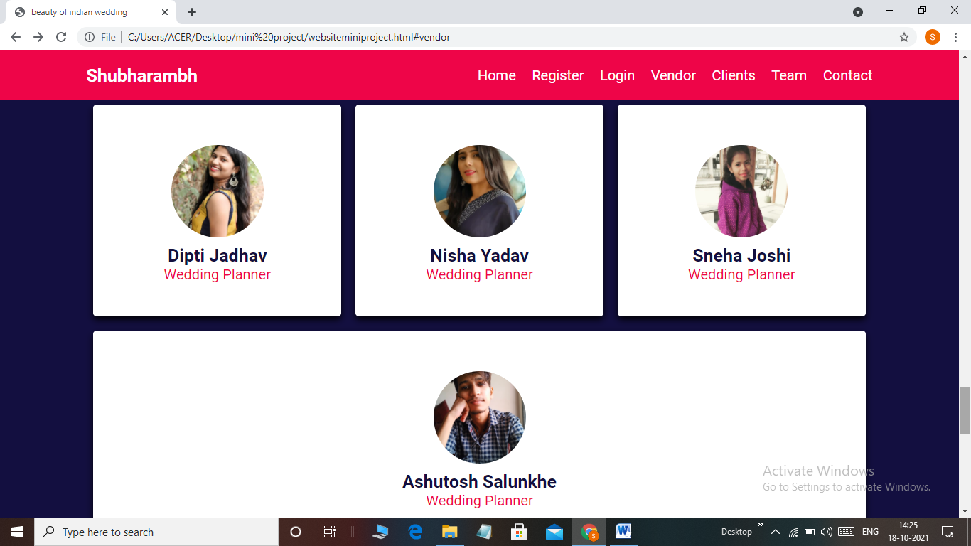

CONTACT US :-

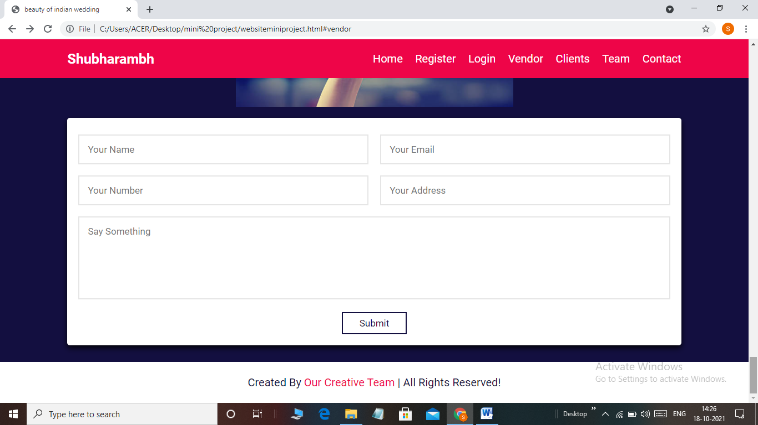

HOME PAGE

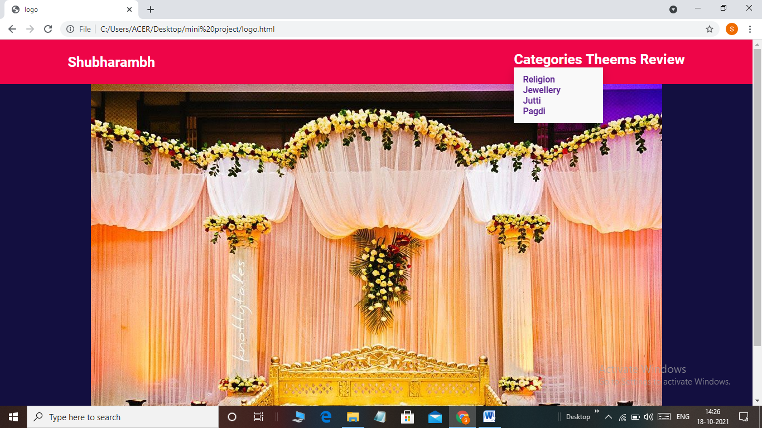

RELIGIOUS WEDDING VENDOR:-

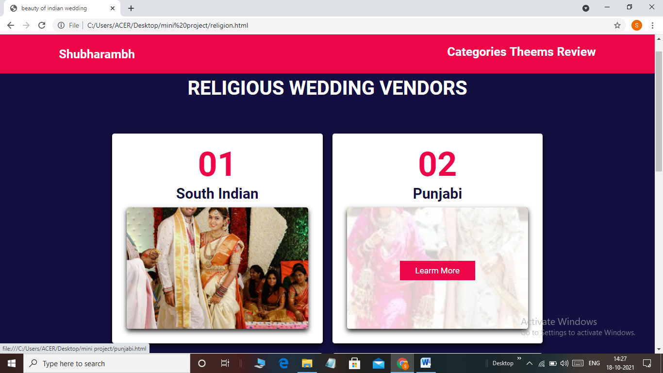

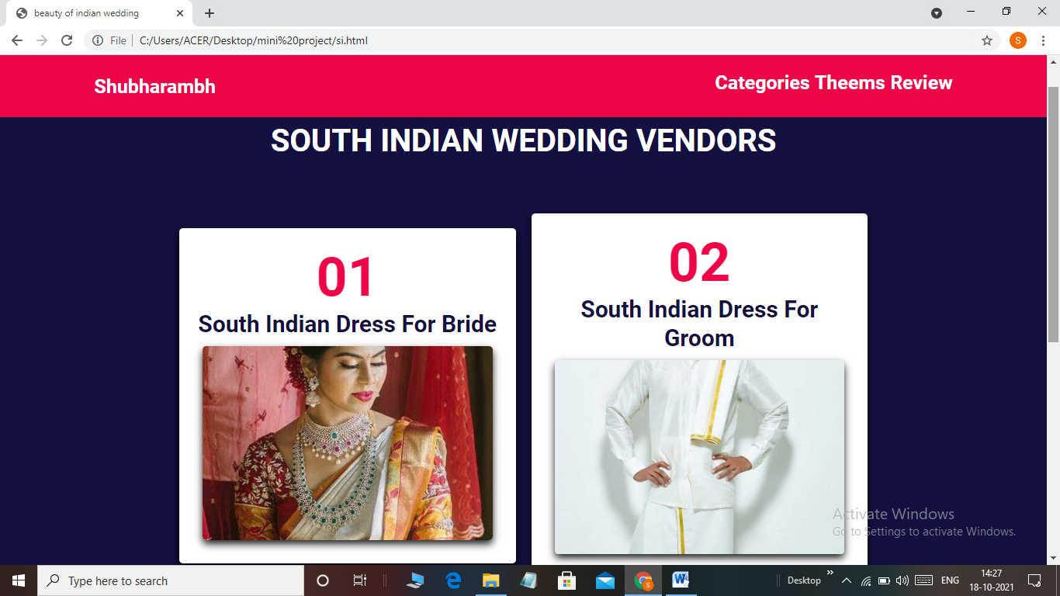

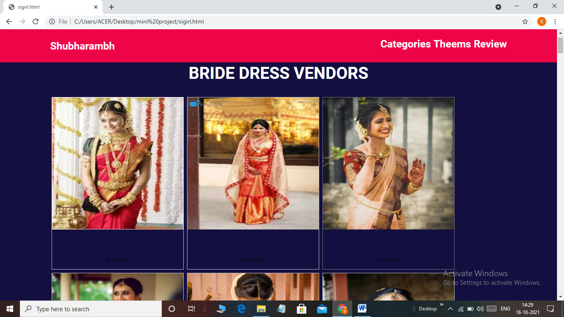

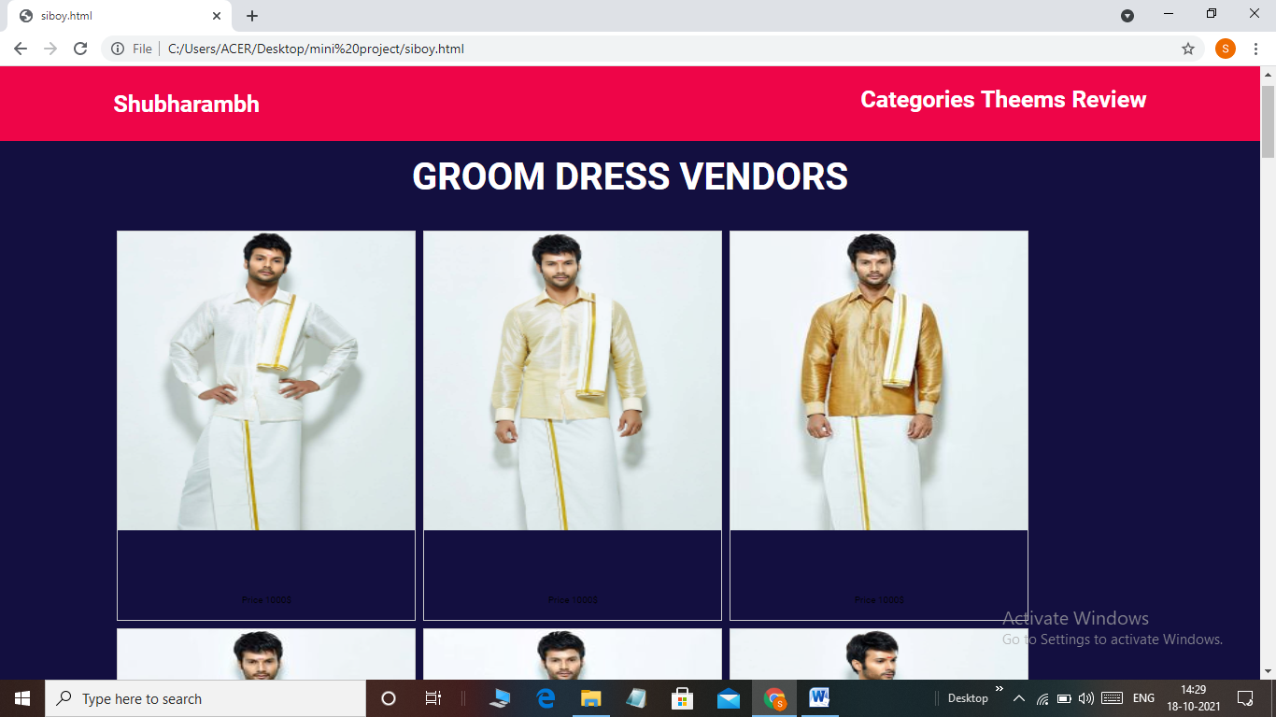

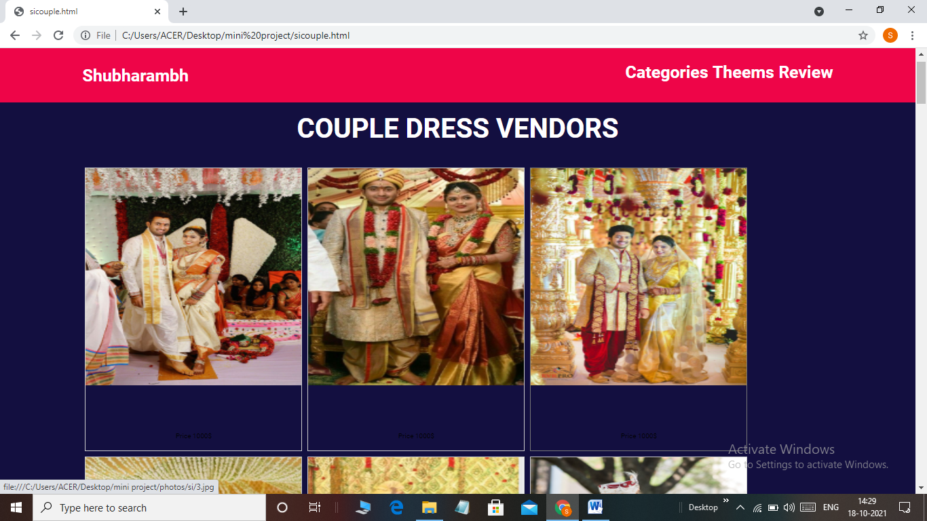

JEWELLERY VENDOR:-

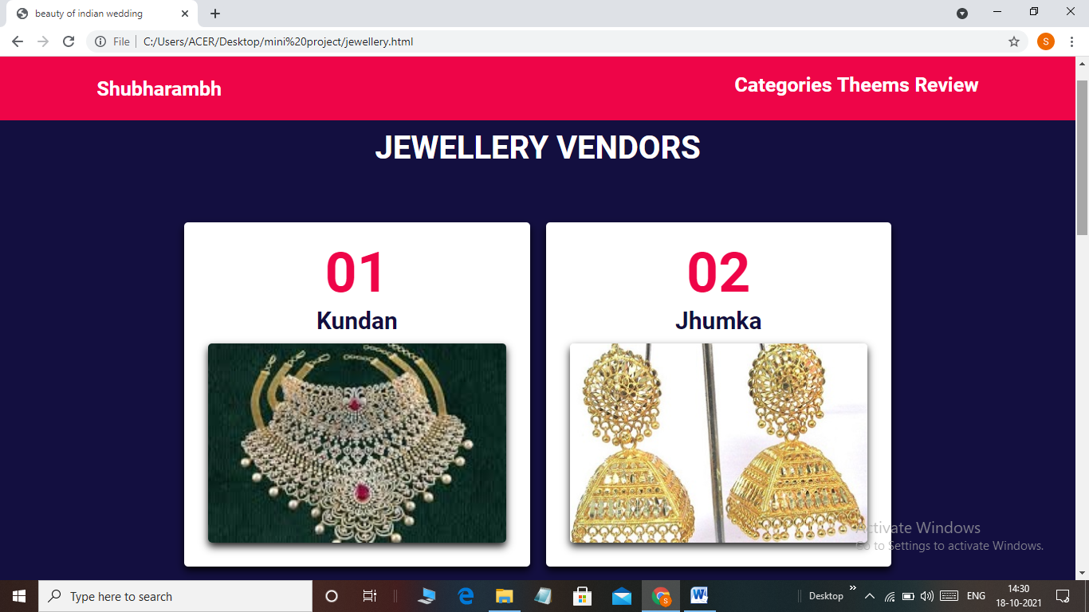

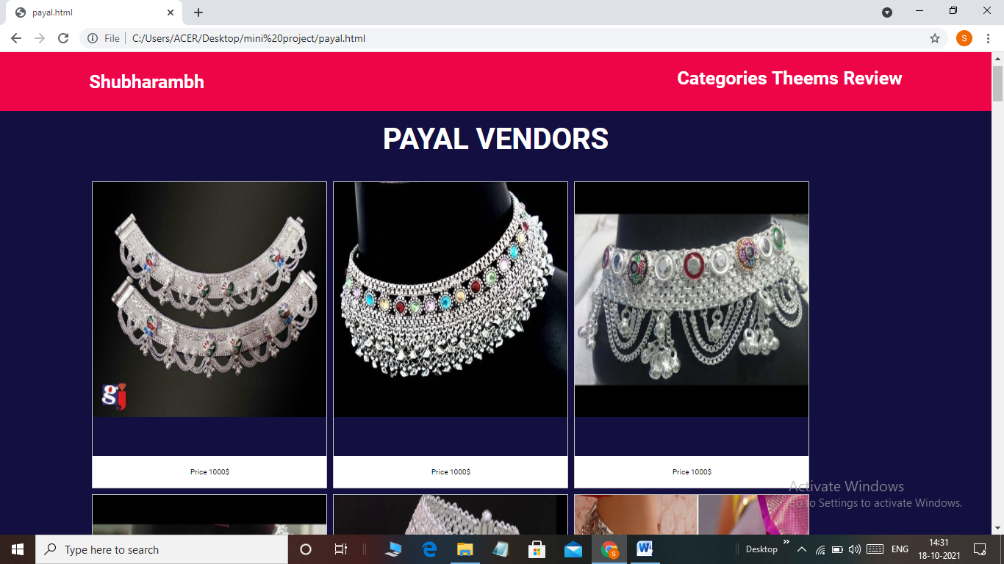

JUTTI/SANDAL VENDOR

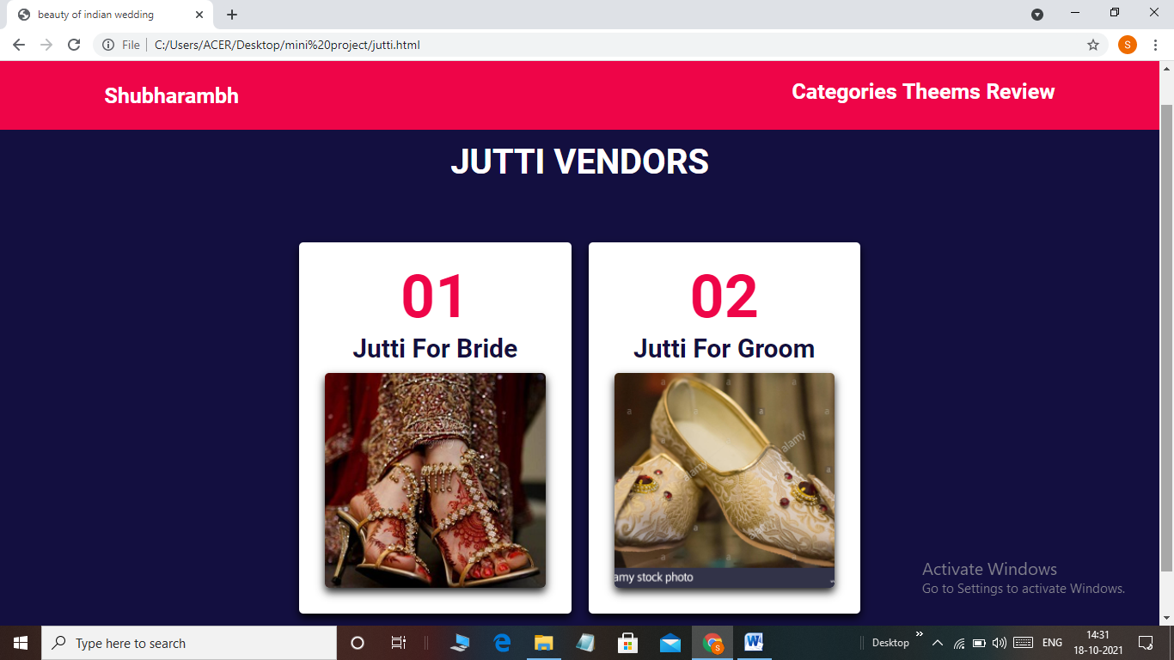

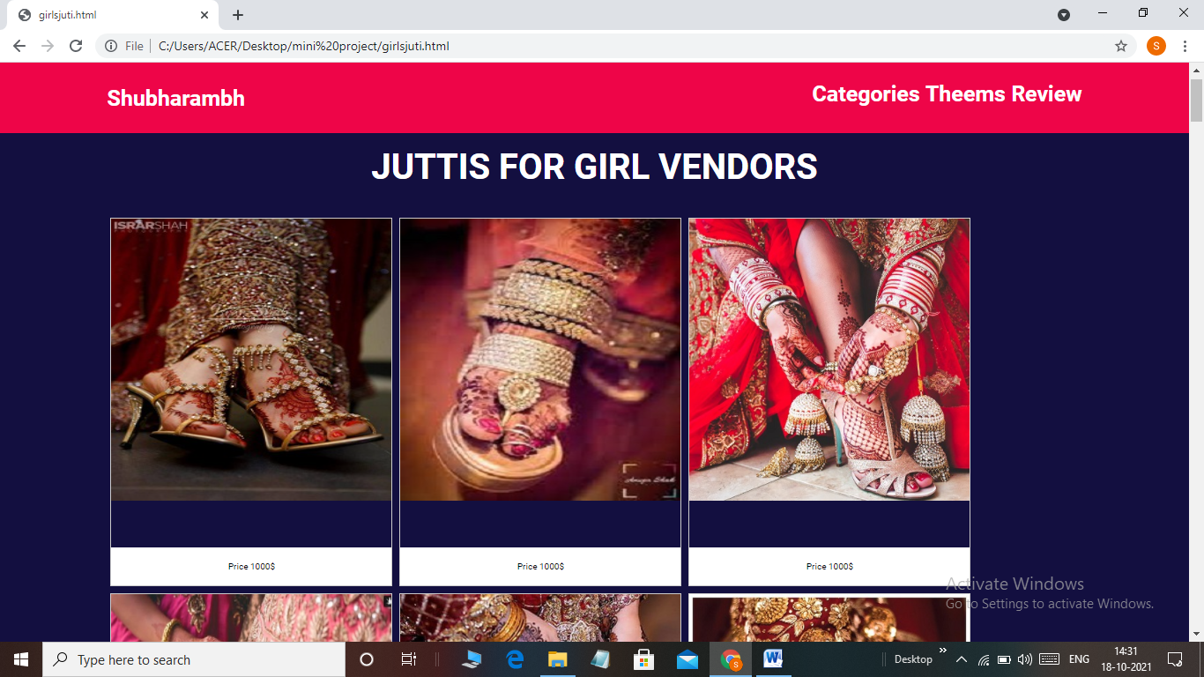

PAGDI VENDOR:-

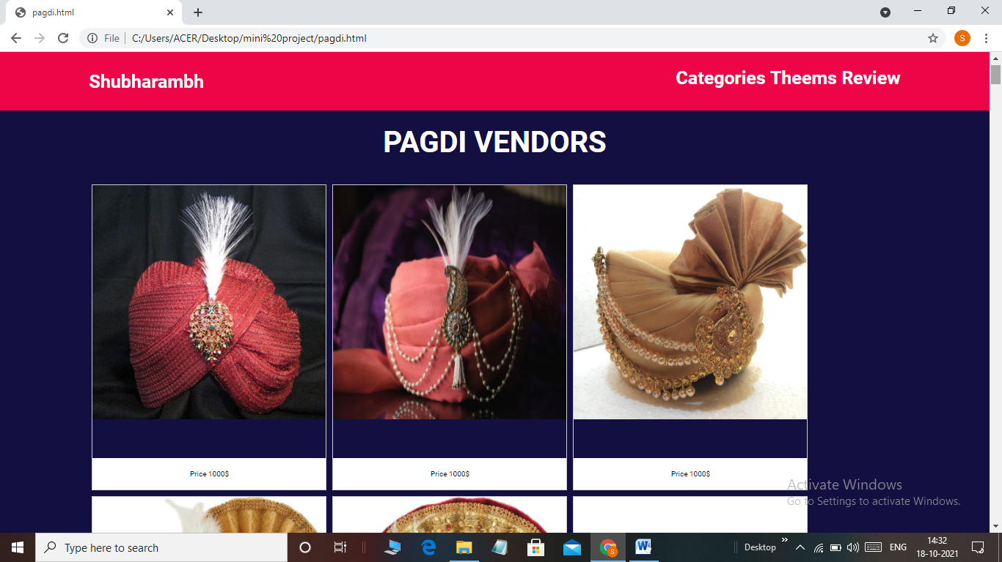

THEMES/ VENUES:-

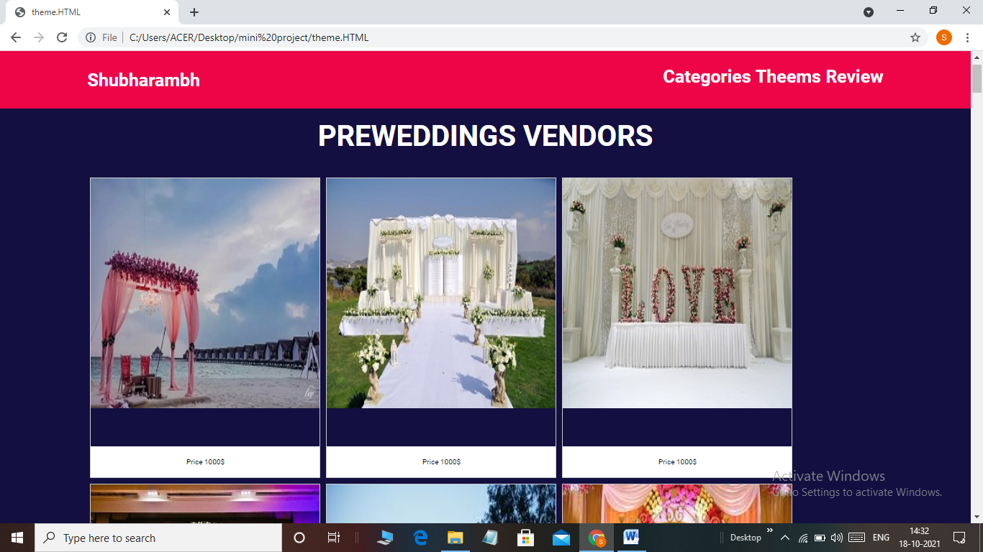

RATING PAGE:-

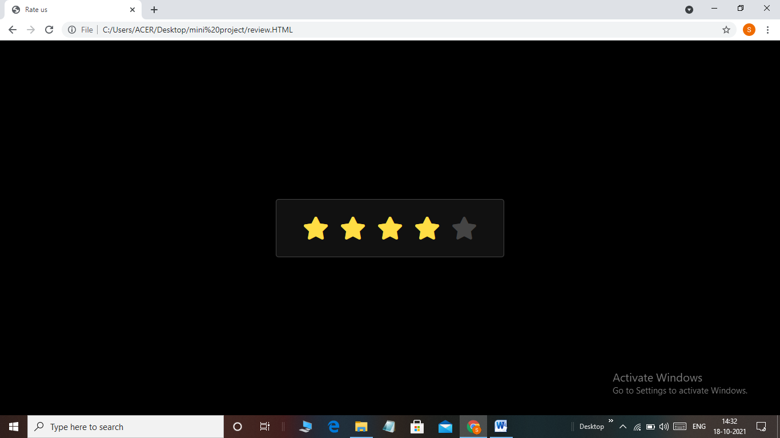

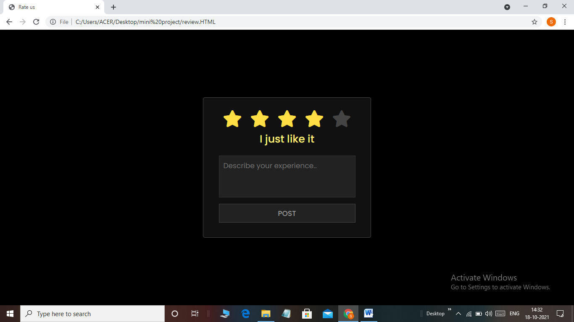

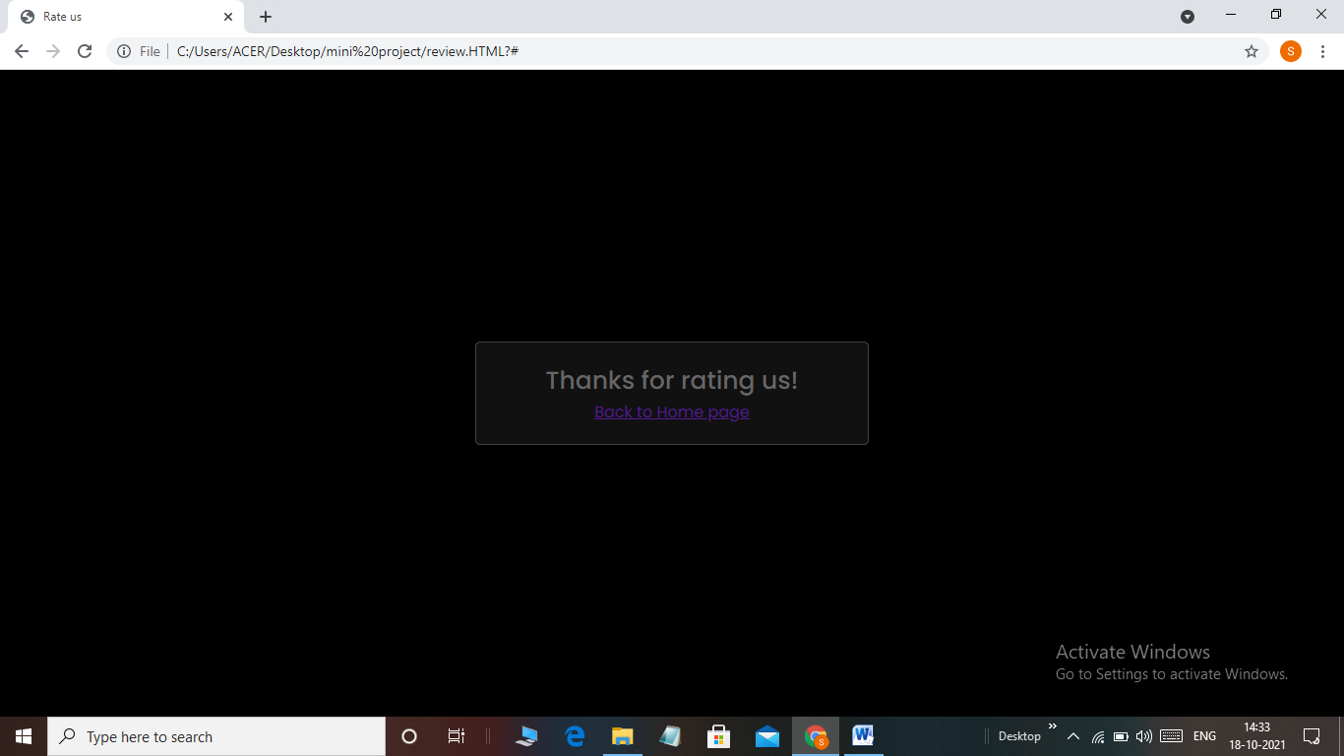

BOOKING PAGE:-

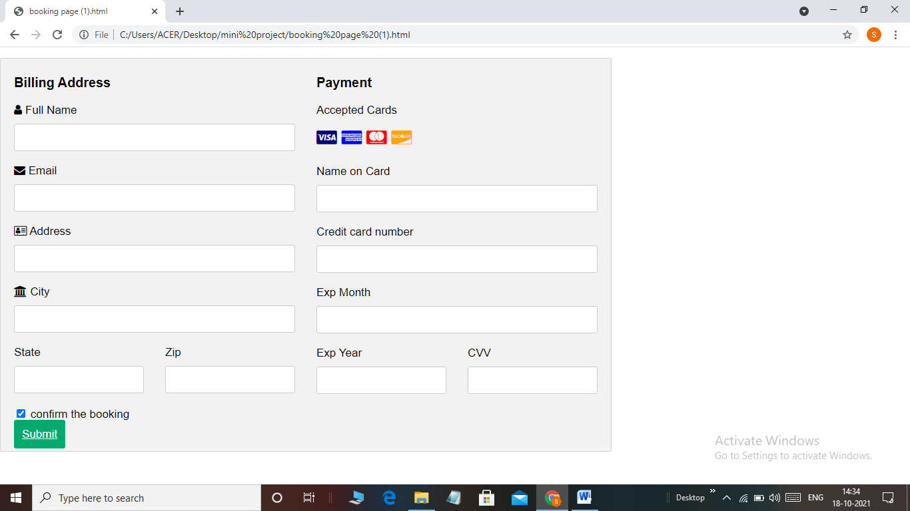

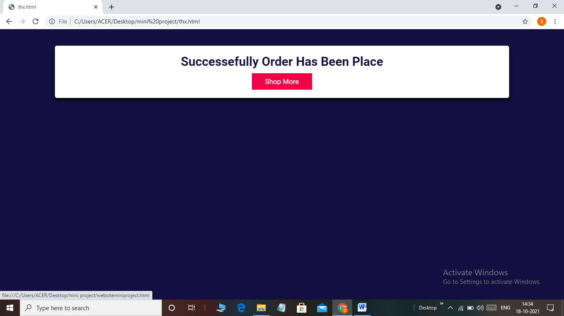

**7. Conclusion**

Successful build of project for WEDDING AND EVENT PLANNING. The wedding planner is a website which helps to organize successful wedding events for users. This application provides an easy way to plan their special events. The user can add all the details of the event and can get the service. The user can select the type of event, type of food to be served, type of decoration and estimated budget. All the details given by users will be verified by admin. Admin will add all the details of the planner based on the requirement of the user and send the user’s event details to the planner. The planner will verify and send his response with a confirmation mail. The user needs to complete the payment process to confirm the order.

**8.References**

The References that have been taken are all from google(www.google.com)

1https://www.google.com/search?q=geeksforgeeks&oq=https%2F%2Fgee&aqs=chrome.1.69i57j0i10i433l4j46i10i433j0i10i433j69i58.11988j0j9&sourceid=chrome&ie=UTF-8

2 https://www.tutorialspoint.com/html/index.htm

3 <https://www.google.com/search?q=codingnepal&oq=coding&aqs=chrome.1.69i57j69i59l2j0i67l2j0i433i512l3j0i457i512j0i402.7608j0j7&sourceid=chrome&ie=UTF-8>